**Process Management Report**

Due Monday, February 18, 2019, before class

Team 2 (Dimitrios Chavouzis, Claire Collver, Clarissa Fung, Drew Hager, Blake Skelton)

**Introduction:**

This report describes Team 2’s management plan for its project to develop a space reservation system for Davidson College.

**1.** **Expected Level of Effort in Person-Months**

|  |  |
| --- | --- |
| **Code** | **LOC** |
| Web app reservation functions | 600 |
| Web app occupancy-check interface | 400 |
| Web app graphics | 300 |
| Database design/sync | 100 |
|  |  |
| **Total:** | 1400 |

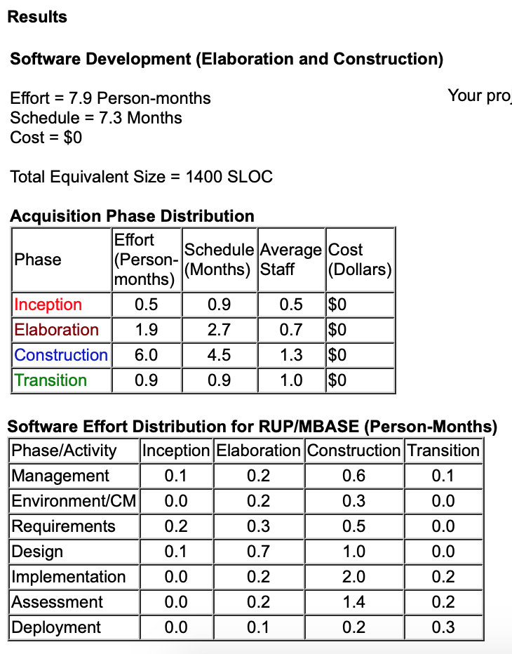

COCOMO II person months: 7.9

**2.** **Overall High-Level Schedule for the Project**

Four iterations, spanning 2-3 weeks each. A total of 10 weeks max because of time constraint. (See number 6 for detailed schedule)

**3.** **Quality Plan**

1. Goal: Intuitive and simple interface that students will want to use.

Plan: Create prototypes to figure out what design works the best. We plan to create at least 4 iterative versions. Test each versions with “student/user focus groups” for ease of use.

2. Goal: Product works for specific user stories/test cases (ex. I want to book a room to study tomorrow) without errors.

Plan: Test each iterative version for a variety of usages (i.e. Example 1: study room; Example 2: club meeting; Example 3: AT sessions; Example 4: expositions).

3. Goal: Create software with minimal errors.

Plan: Use pair programming to catch and resolve mistakes as they are created.

4. Goal: Remove errors that are discovered.

Plan: Employ other students as testers for each iteration and fix the software as needed.

**4.** **Risk Management Plan**

1. Underestimated effort required due to lack of experience
   1. Probability: high (we do not have the skills to ensure that our schedule is viable)
   2. Loss: medium (we may not implement every iteration we currently have planned)
   3. Mitigation Plan: If necessary, we can eliminate the last iteration and spend our time completing earlier iterations.
2. Users do not use the system to reserve rooms or update occupancy status
   1. Probability: high (more time and institutional support would be required for widespread adoption)
   2. Loss: medium (without users filling in occupancy status of rooms, our site will not be able to provide accurate data)
3. We cannot obtain information to populate the database
   1. Probability: low (the data we require is fairly accessible)
   2. Loss: high (without a working database, our project cannot function)
   3. Mitigation Plan: We will make connections with the Davidson staff in charge of EMS and ensure that we will have access to the required data. In a worst-case scenario, we could attempt to use the database associated with EMS directly.
4. Davidson prefers that study rooms remain first-come first-serve
   1. Probability: high (the current first-come first-serve system is working fine)
   2. Loss: low (our project can function regardless of institutional support)
   3. Mitigation Plan: We could potentially market our project to other institutions
5. Speed - the database is prohibitively slow for use in the web client/app
   1. Probability: low (DBMS is optimized for speed)
   2. Loss: medium (users will be less likely to use a frustratingly slow interface)

**5.** **Project Monitoring Plan**

Measurements:

1. Milestone completion: meet deadlines for all five major milestones.
2. Log hours/week: Keep an updated log of who is working on what, at which times, and the progress/completion of each task.

Major Milestones:

1. Barebones web app and database synced by **21 March.** (Build Milestone)
2. “Check Occupancy” functional with two buildings by **4 April**. (Build Milestone)
3. Have “Make Reservation” functional by **18 April.** (Build Milestone)
4. Finish graphics for “Make Reservation” by **2 May**. (Test Milestone)
5. Finish graphics for “Check Occupancy” by **10 May**. (Test Milestone)

Steps if Not On Track:

1. Talk to professors and ask for help.
2. Use our mitigation plans.
3. Prioritize this project until we get back on track (invest additional time).

**6.** **Detailed Scheduling**

|  |  |  |
| --- | --- | --- |
| *We plan to update this detailed schedule after the completion of each iteration. Major milestones are bolded.* | | |
| **1** | **Week 1**  (22-28 FEB) | Create a database and populate it with information for one floor of one building. |
| **Week 2**  (1-14 MAR) | Complete simple web app (not yet linked to the database). |
| **Week 3**  (15-21 MAR) | **Barebones web app and database synced**. First iteration complete. |
| **2** | **Week 4**  (22-28 MAR) | “Check Occupancy” working, takes user to a table with room numbers and available/not available. |
| **Week 5**  (29 MAR - 4 APR) | Populate the database further with 2 entire buildings and have **“Check Occupancy” able to toggle between the buildings.** Second iteration complete. |
| **3** | **Week 6**  (5-11 APR) | “Make a Reservation” working, takes user to a page with (nonfunctional) buttons to select the building, date, time, and duration. |
| **Week 7**  (12-18 APR) | Have buttons functional and available rooms based on input shown. **Be able to make a reservation (write to database).** Third iteration complete. |
| **4** | **Week 8**  (19-25 APR) | Work on graphics for “Make a Reservation”. |
| **Week 9**  (26 APR - 2 MAY) | **Finish graphics for “Make a Reservation”** Begin graphics for “Check Occupancy.” |
| **Week 10**  (3-8 MAY) | **Finish graphics for “Check Occupancy.”** Fourth iteration complete. Graphics up to standards. |